To Supply Leftover Food to Poor

College name: Vidyasagar College of Arts and Science College Code: bru30

Team ID: NM2025TMID26923

Team Members:4

Team LeaderName:APARNA M

Email: [aparnamohanraj2005@gmail.com](mailto:aparnamohanraj2005@gmail.com)

Team Member1: SANTHOSH KUMAR R

Email: [SK6340001@gmail.com](mailto:SK6340001@gmail.com)

Team Member2: MAHESH KUMAR S

Email: [mmahesh3213@gmail.com](mailto:mmahesh3213@gmail.com)

Team Member3: ARUN KUMAR T

Email: [arunkumarrithika51@gmail.com](mailto:arunkumarrithika51@gmail.com)

1. INTRODUCTION:
   1. Project Overview:

Our CRM project focuses on streamlining the process of collecting and distributing leftover food to underprivileged communities. The system is designed to connect donors (such as restaurants, hotels, and households) with NGOs and volunteers who help in food distribution. Key features include donor and beneficiary management, real-time food availability tracking, automated pickup and delivery scheduling, and reporting tools to monitor impact. This CRM addresses the business need of reducing food wastage while ensuring surplus food reaches people in need efficiently and transparently.

* 1. Objectives:

The main objective of building this CRM is to create an organized platform that efficiently manages the collection and distribution of leftover food. It aims to simplify communication between donors, NGOs, and volunteers while ensuring transparency and accountability in the process. By automating scheduling, tracking donations, and monitoring food distribution, the CRM reduces manual effort and operational delays.

The business value lies in minimizing food wastage, maximizing resource utilization, and delivering timely support to the needy, making the entire system more reliable, efficient, and impactful.

DEVELOPMENT PHASE:

Creating Developer Account:

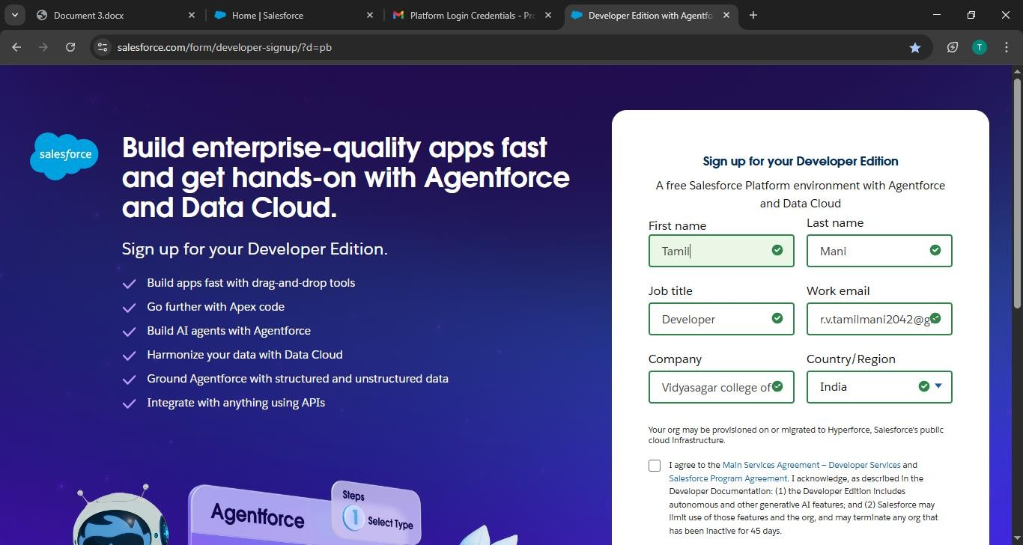By this URL: <https://developer.salesforce.com/signup>

Created Objects: Venue, Drop-off point, Task, Volunteer, Execution Detail.

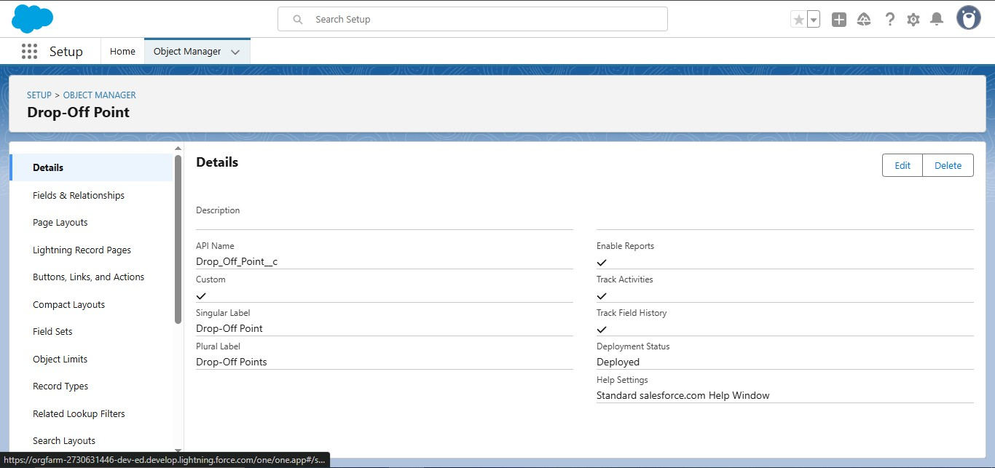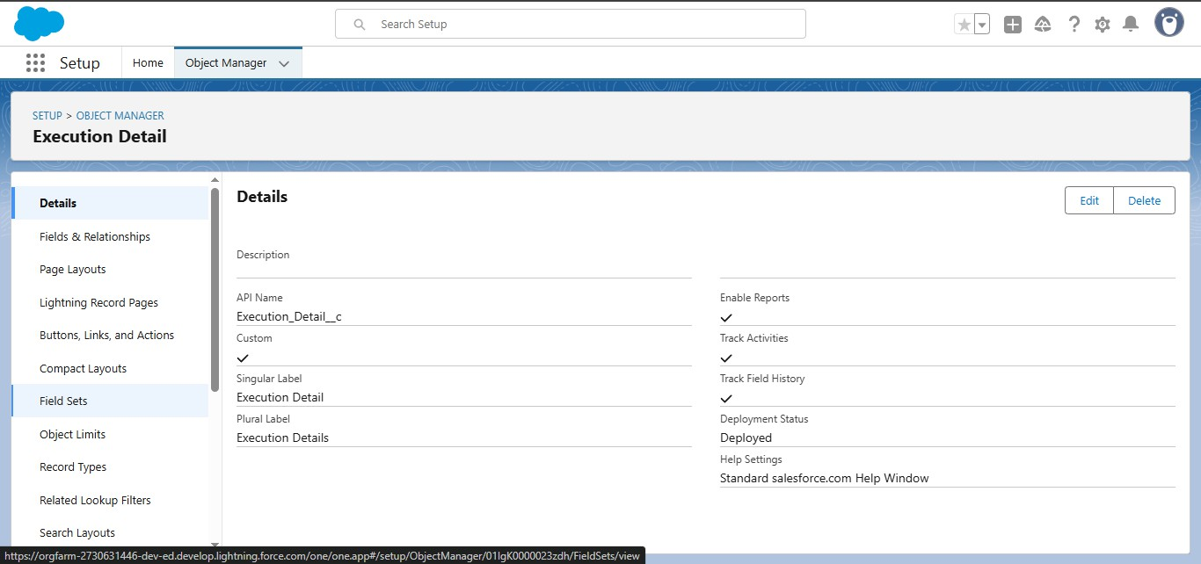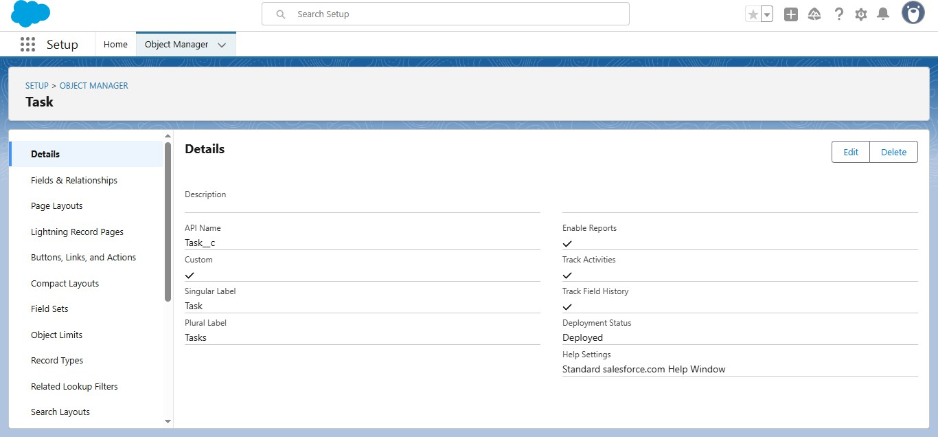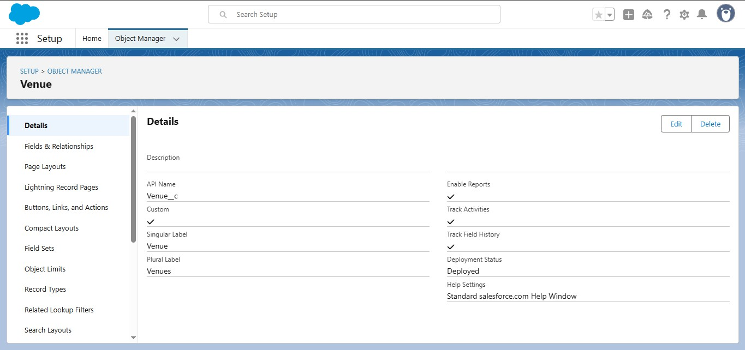

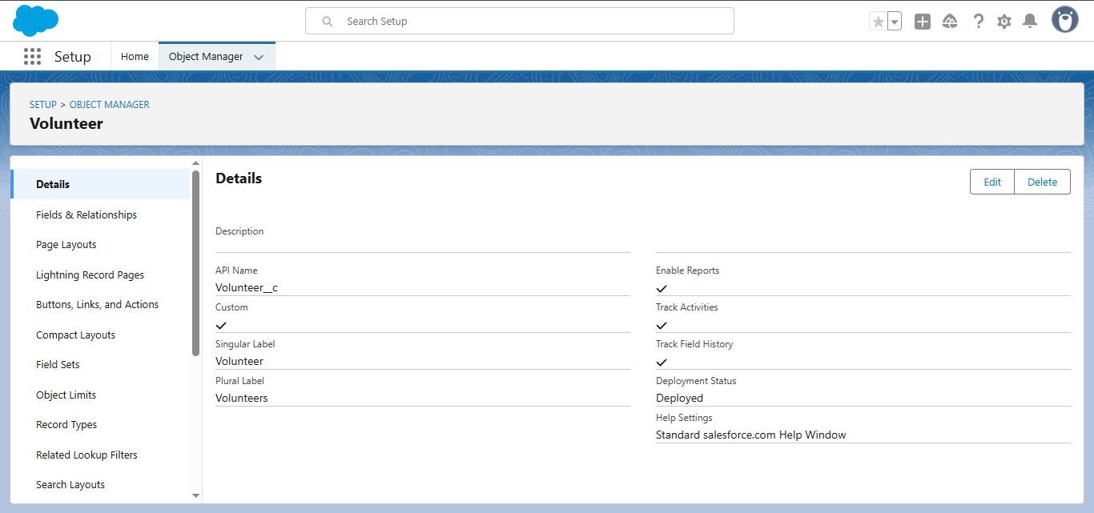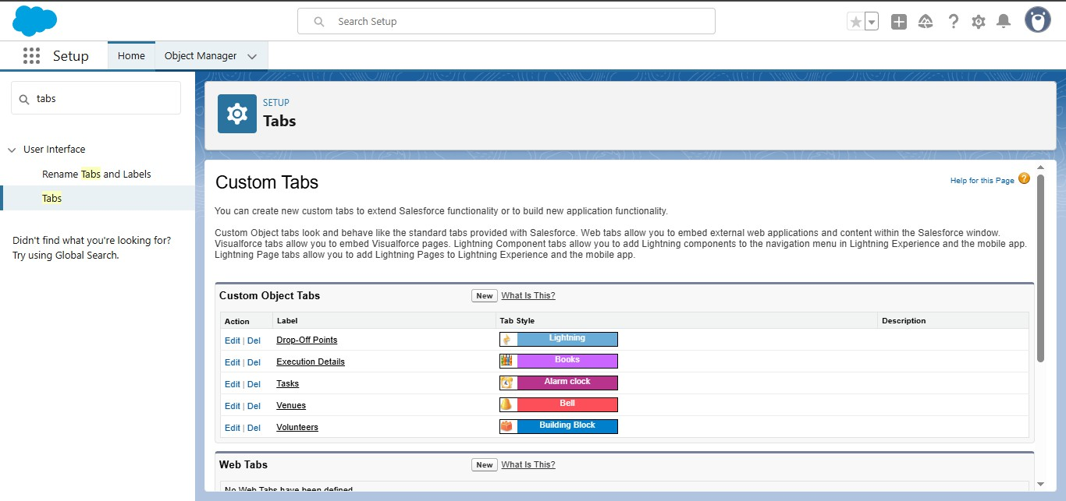Created Tabs for Venue, Drop-off point, Task, Volunteer, Execution Detail.

We have successfully created a “Food Connect” app.

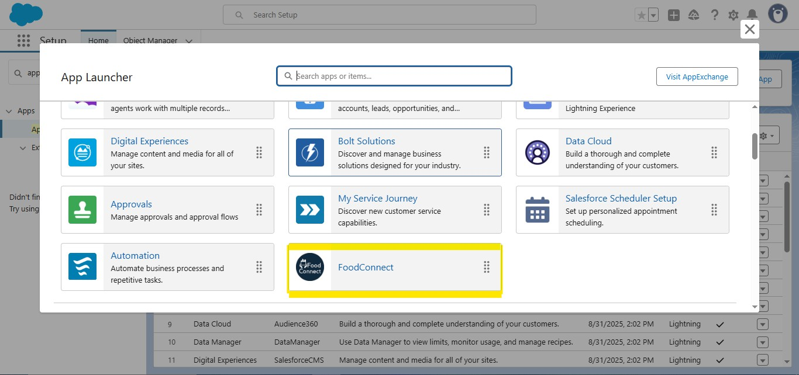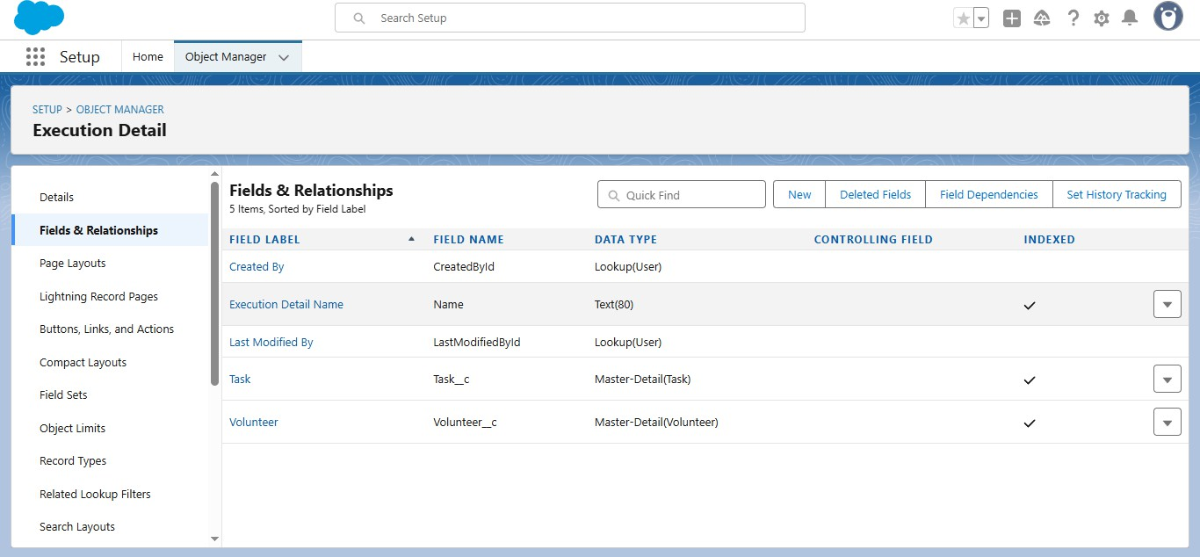Creation of Relationship fields in objects (Venue, Drop-off point, Task, Volunteer, Execution Detail)...

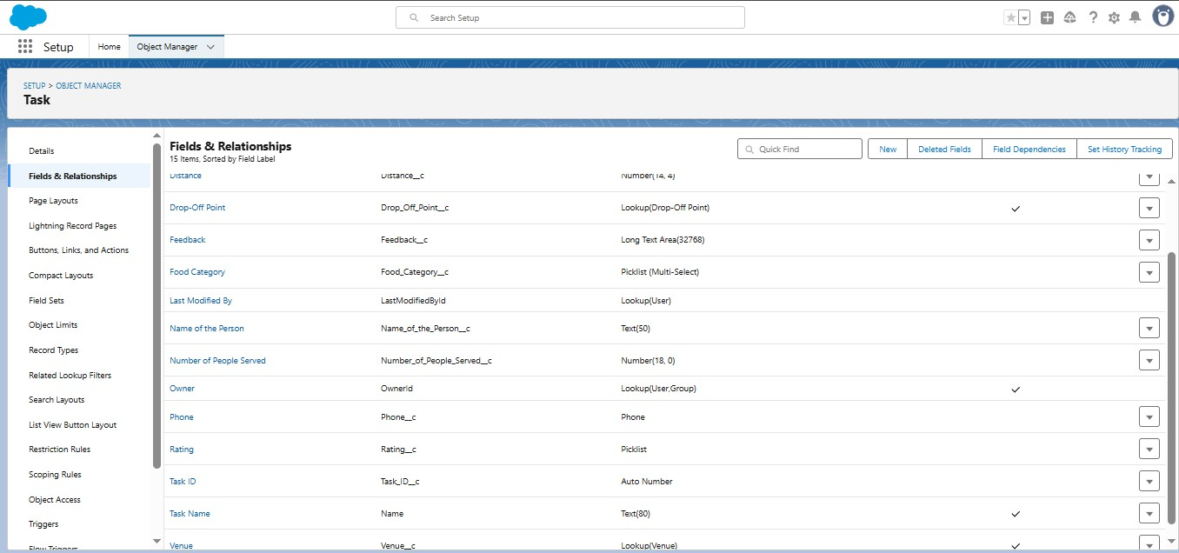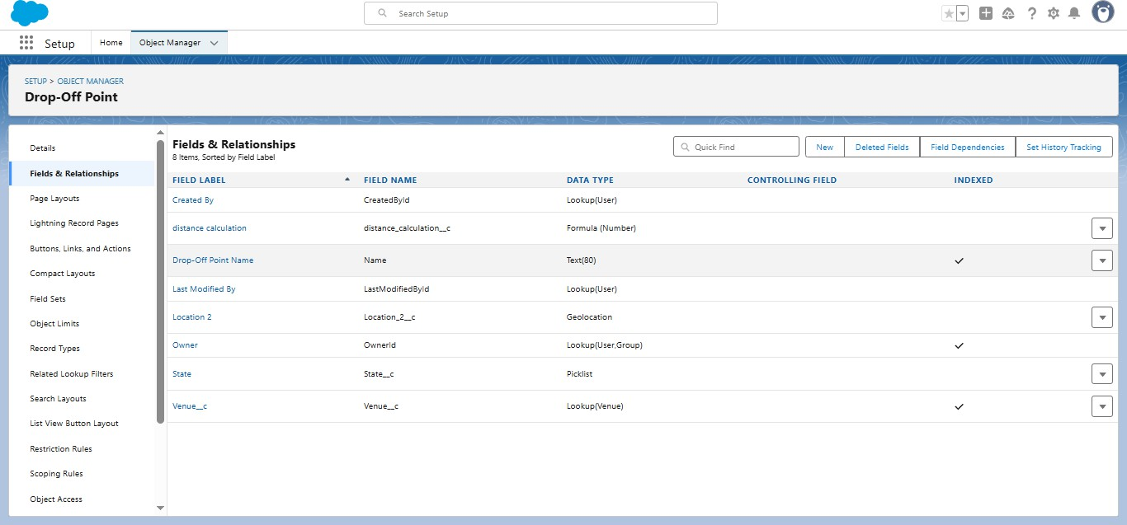

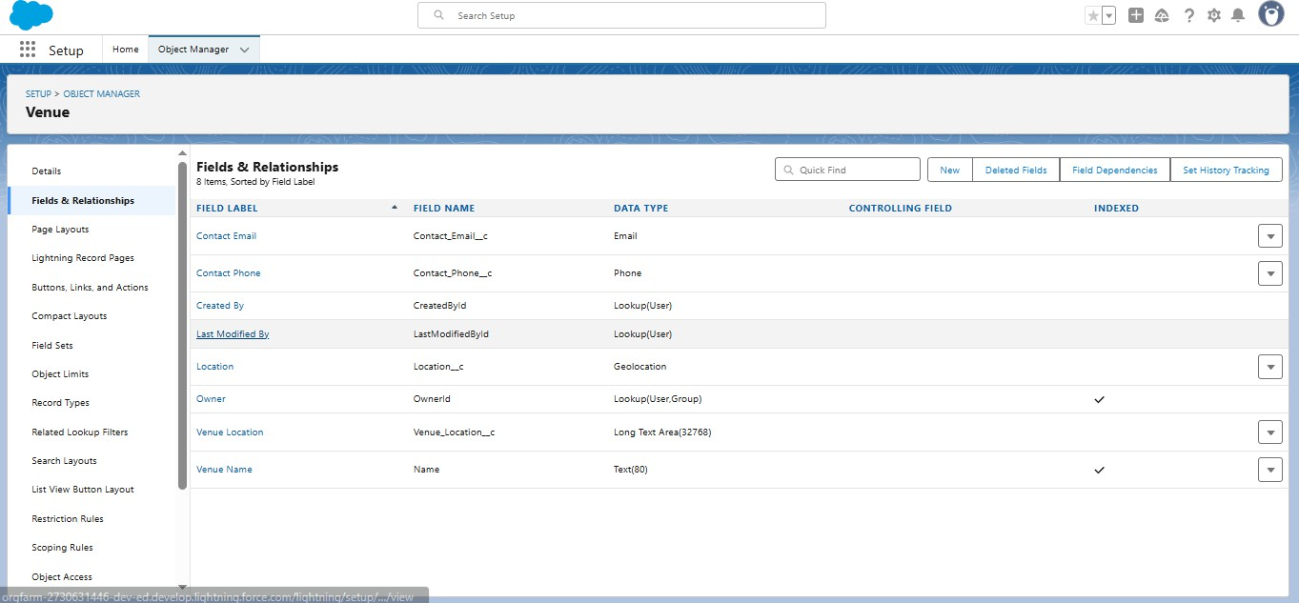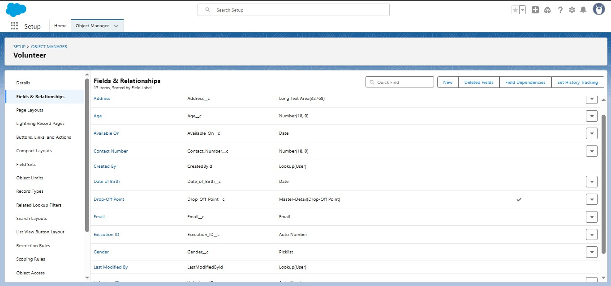

Creating Flows and How it works:

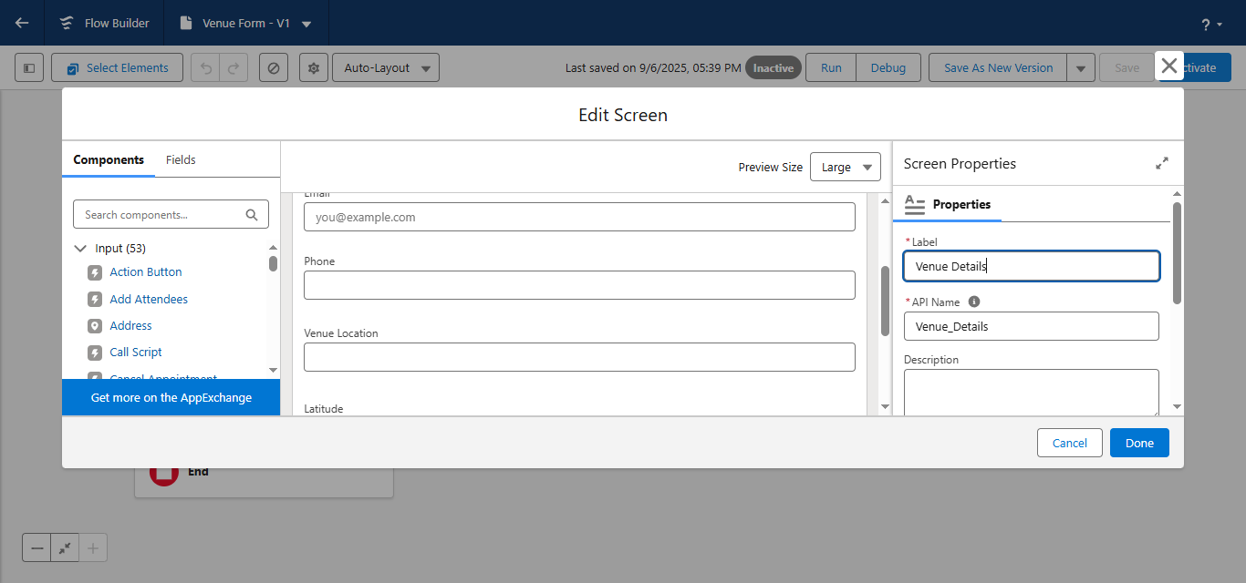First the flow starts and flows to Venue Details screen element, now the screen element gathers the details of Venues.

The flow flows to Records, This Record named “Create venue record” is used to store the details of the venue.

Created the NGOs profile...

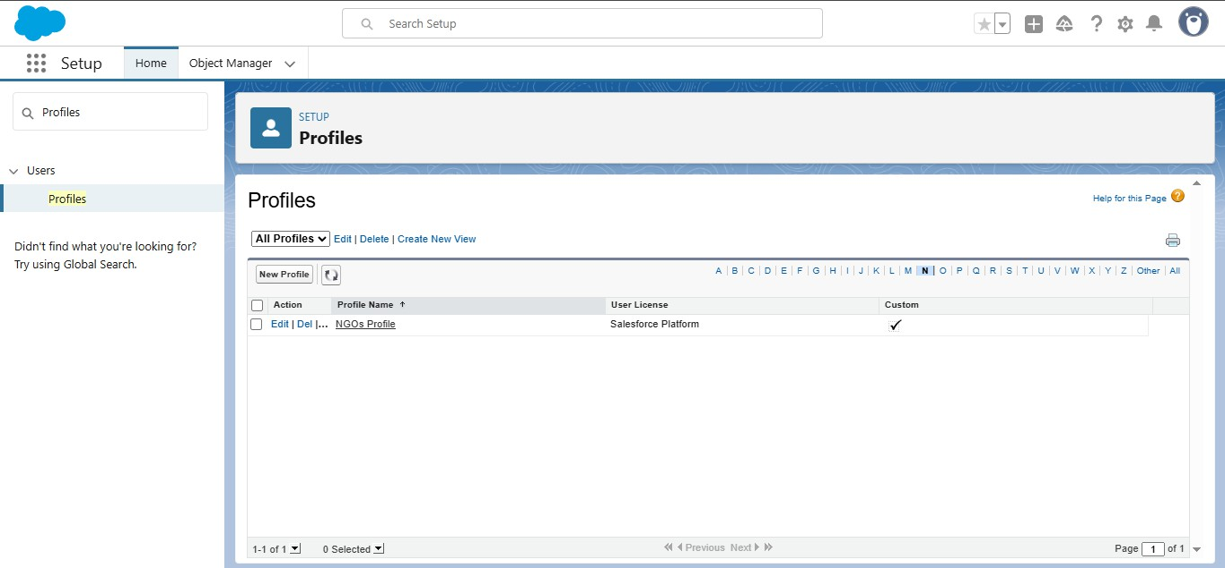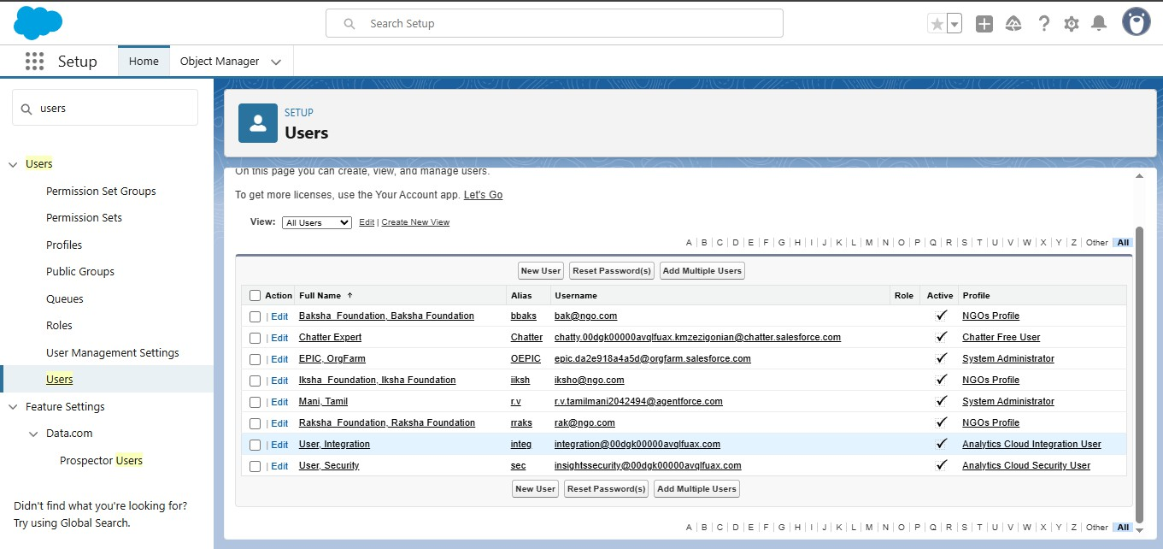Created the three users... named iksha Foundation, Raksha Foundation, Baksha Foundation.

Created some public groups...

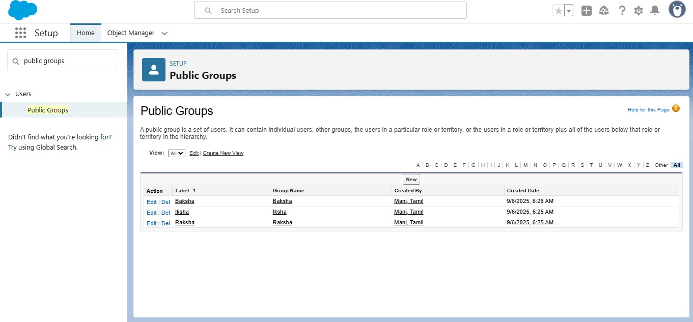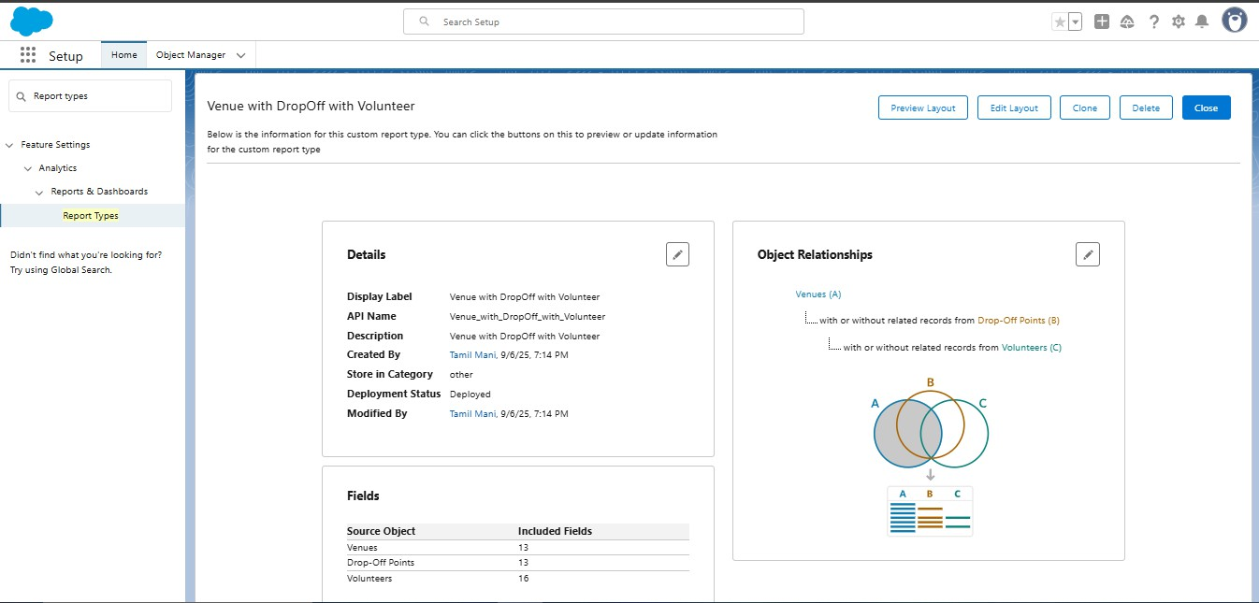We have successfully created report types...

Created reports:

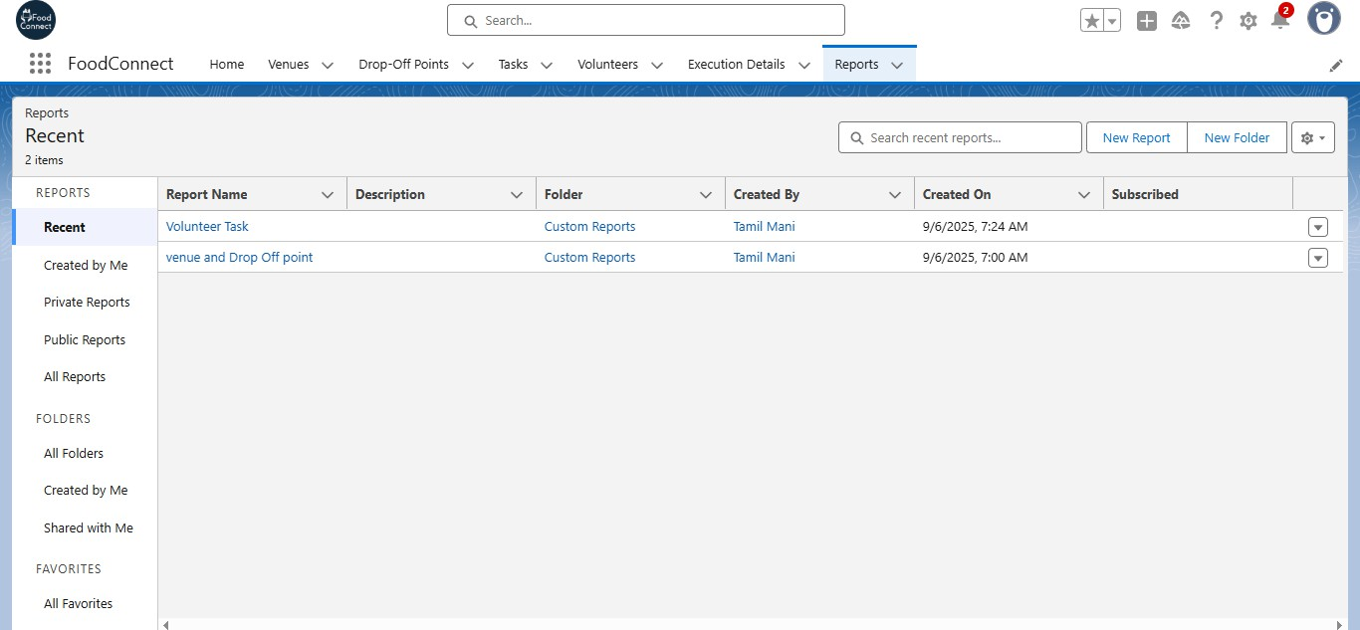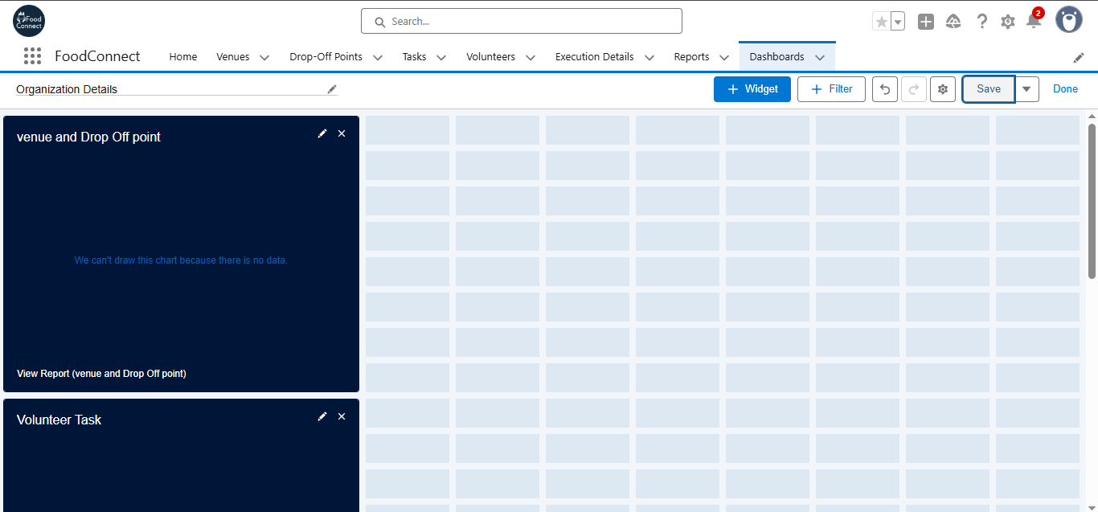Created reports for the dashboards, with the reports we were able to give charts..

Sharing rules are used to efficiently share the food reserves with public volunteers to supply for the poor the app manages the calculation by itself.

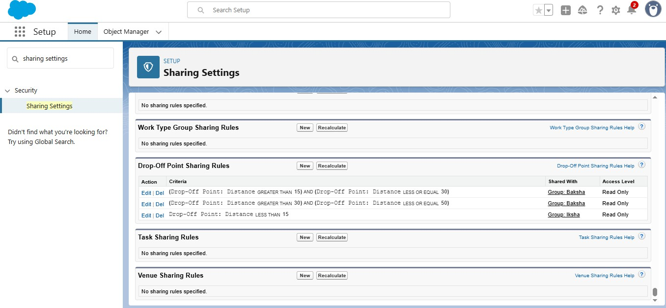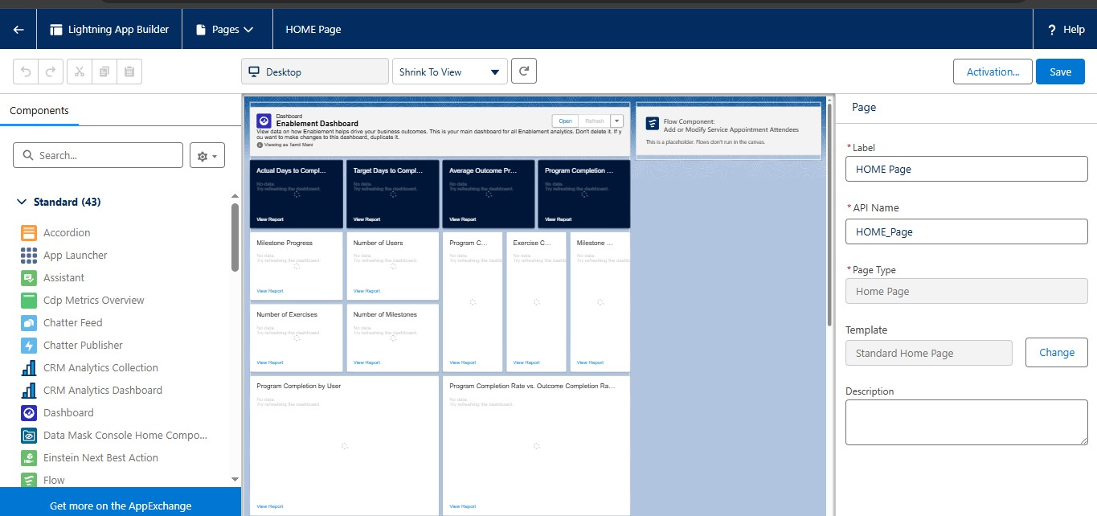Home page of the Food Connect...

Codes:

Creating a trigger:

creating a trigger to automatically calculate distance when entered...

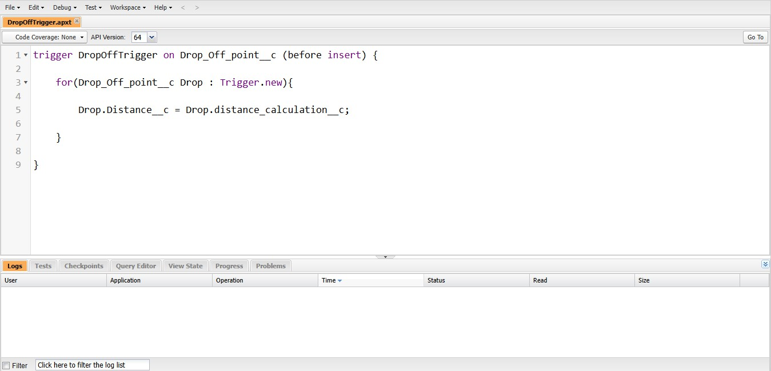

Testing the App:

Testing to see if the app works, giving some data to the object to see if the Tabs in the App works. It works like a butter.

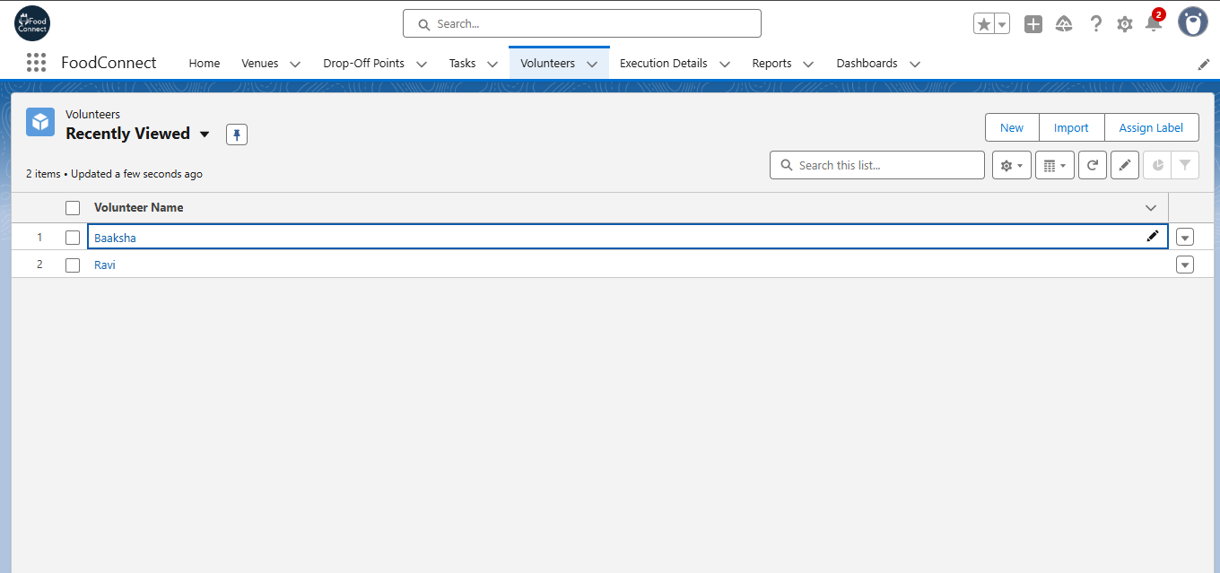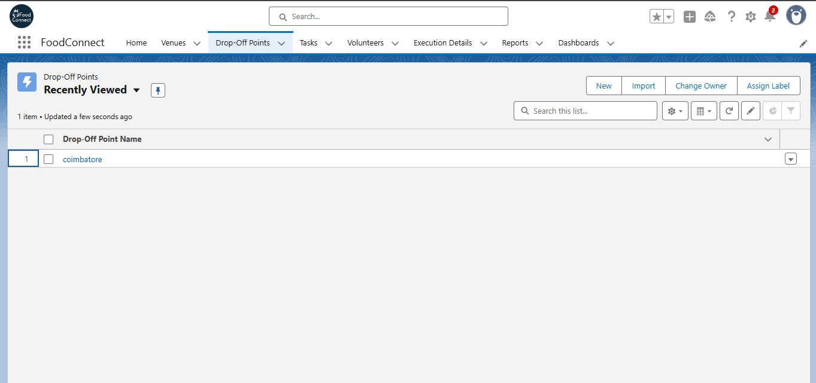

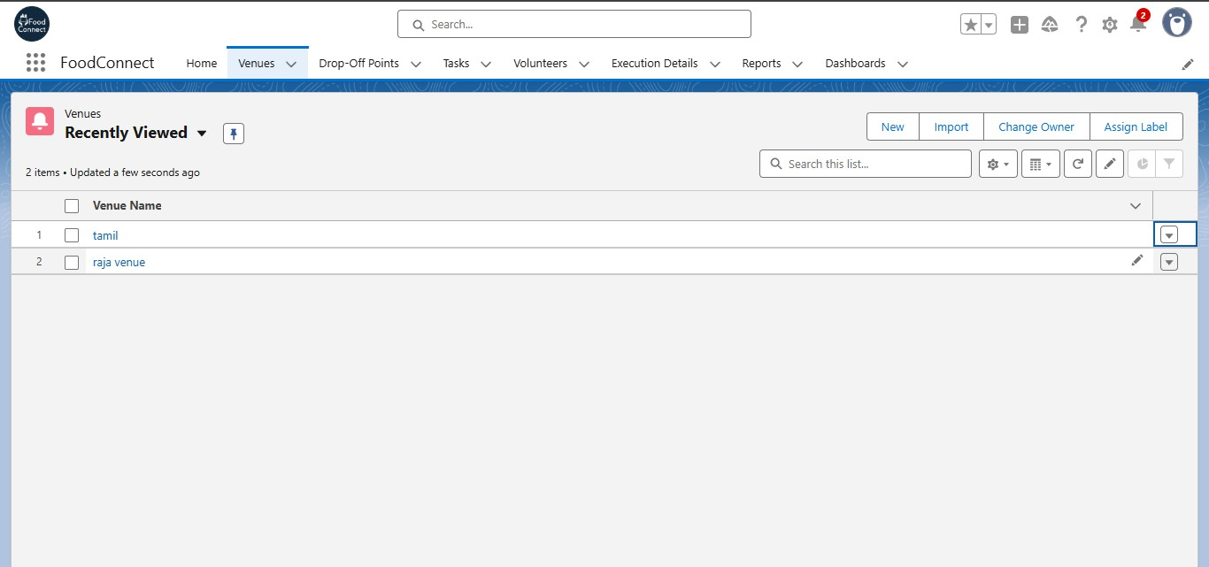The data are adding without any problem. Testing complete..

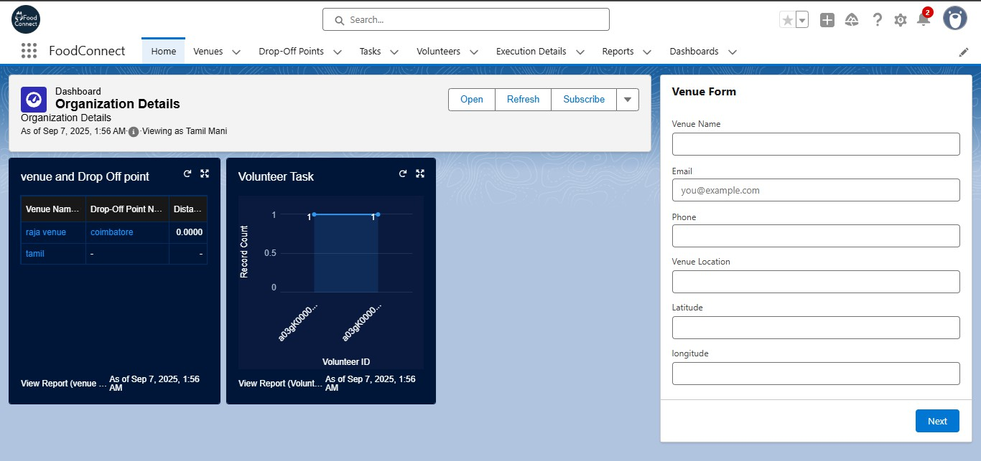Output:

Conclusion:

The CRM project successfully demonstrates how technology can be used to connect food donors, volunteers, and NGOs to ensure that leftover food is efficiently distributed to the underprivileged. While not all planned features could be fully implemented within the given time, the application establishes the foundation for donor and volunteer management, task tracking, and execution monitoring.

The project highlights the potential of CRM systems in reducing food wastage and supporting social impact initiatives. Future enhancements can focus on expanding reporting capabilities, strengthening relationships between objects, and integrating automation to improve scalability and efficiency.